**Introduction to MATLAB**

**Objective:**

To provide hands-on practice in MATLAB, covering basic commands, matrix operations, image processing, and graph plotting, giving a strong foundation for further image processing work.

MATLAB Windows Overview: Command Window, Workspace and Editor.

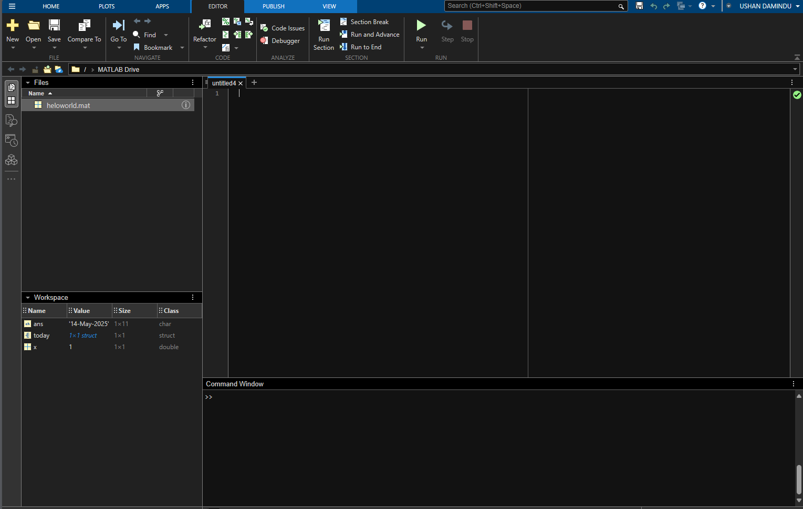

[MATLAB Home](https://matlab.mathworks.com/?elqsid=nasqtlpwcy6dm8bibemt):- using this link you can work online without install MATLAB (only for 20 hours per month)

**Command Window**

This is where you type commands and see results immediately. For example:

This will display **Hello World!** in the Command Window.

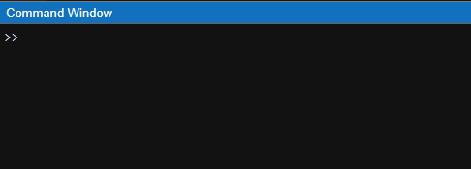**2. Workspace**

The **Workspace** stores all the variables you've created during the session. You can see them by typing:

Think of it as a **storage area** where MATLAB keeps track of your work.

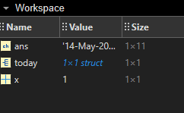

**Editor**

The **Editor** allows you to write and save scripts (MATLAB programs). Instead of typing commands one by one, 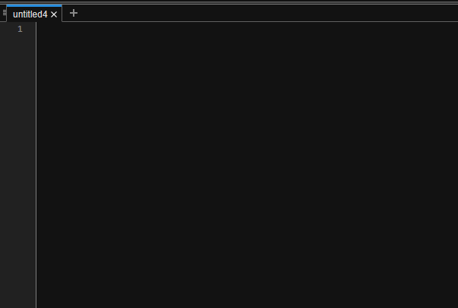

you can write a full script and run it all at once.

**1.Display**

- Run a simple command like **disp('Hello World!')** in the Command Window.

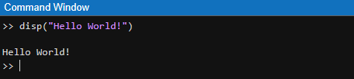

**2. Date Command**

- Use the **“date”** command to display today’s date.

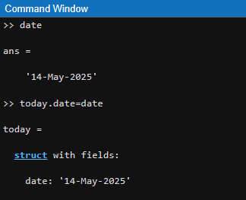

This command creates a **structure** named Today, with a **field** named date, and assigns it the value '14-May-2025'.

**3. Defining Variable and Case Sensitivity.**

- Define variables x = 5, Redefine a variable using uppercase (X = 10), then display both **x** and **X** to observe case sensitivity.

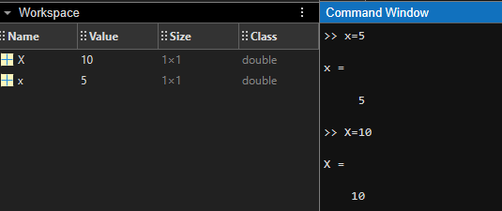

4. Usage of Semicolon.

- Define z = 25; and observe that no output is displayed.

- Remove the semicolon from the end of the statement and re-run to see the difference.

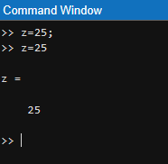

5. Diary Command: It is used to record command window session into a text file.

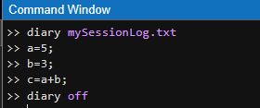 - Run diary command and save the text file as **mySessionLog.txt**

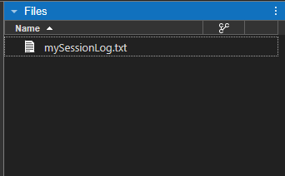

6. Usage of who, whos, clc and clear Commands.

- Create multiple variables (a = 1, b = 2, c = 3).

- Use who and whos to inspect the workspace and note the differences.

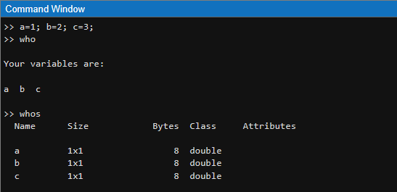

- **(clc )** Clears the command window**, (clear)** Clears all variables

7. Arithmetic Operations.

- Perform arithmetic operations a = 15.5 and b = 7.2

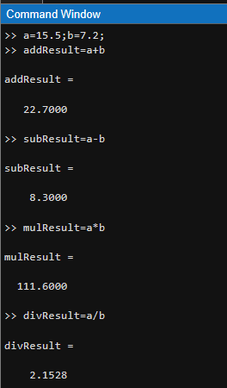

-Compute power and exponential

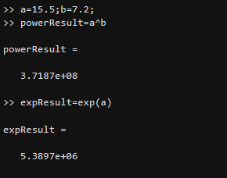

8. Creating and Accessing Vectors.

- Create a row vector and a column vector called V1 and V2 respectively. Call the 2nd element of each vector.

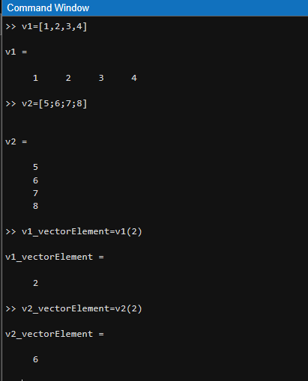

- Create row vector and column vector using zeros command.

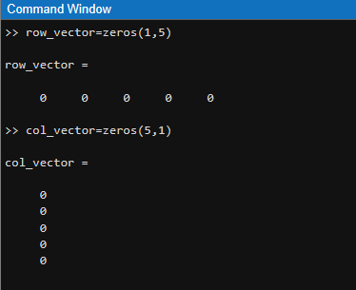

- Print 0 to 10 numbers.

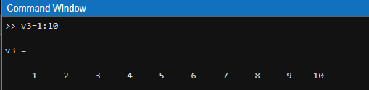

- Print [0 2 4 6 8 10]

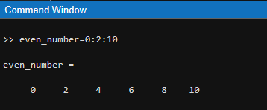

9. Creating Matrices.

- Create 3 X 3 matrix.

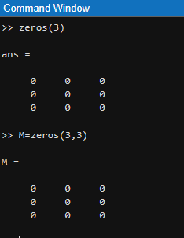

- Create matrix S = $\begin{matrix}1 & 2 & 3 \\ -5 & 0 & 5 \\ 10 & 9 & 8\end{matrix}$ $\begin{matrix} 4 \\ 10 \\ 7\end{matrix}$

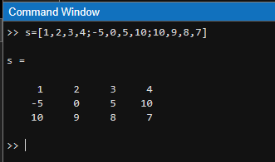

-Create a random matrix M = (3 X 3) and access the element M(3,2) and display.

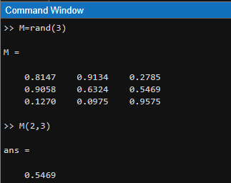

- Add value 2 with each element in the matrix M.

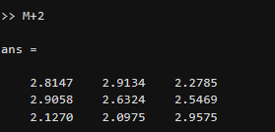

10. Reading, Displaying and Writing Images.

Fist download image using this command or you can get any image and paste in to current directory

url = "https://th.bing.com/th/id/R.2209785b9f654b33964f56213fccf222?rik=JmMpfQtnjhOadw&pid=ImgRaw&r=0";

filename = "image.jpg";

websave(filename, url);websave(filename, url);

- Read an image file (image.jpg) and display it.

- Save the displayed image to a new file.

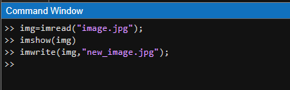

In this window you can see image

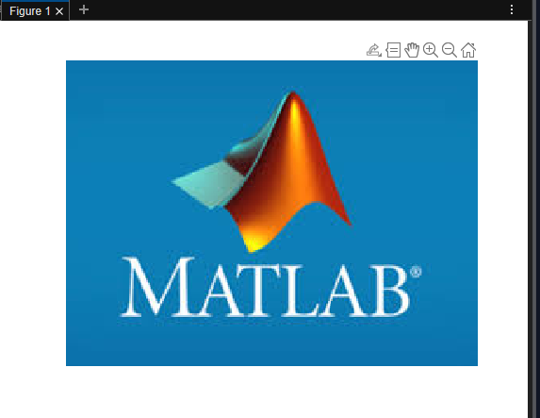

11. Plotting Graphs.

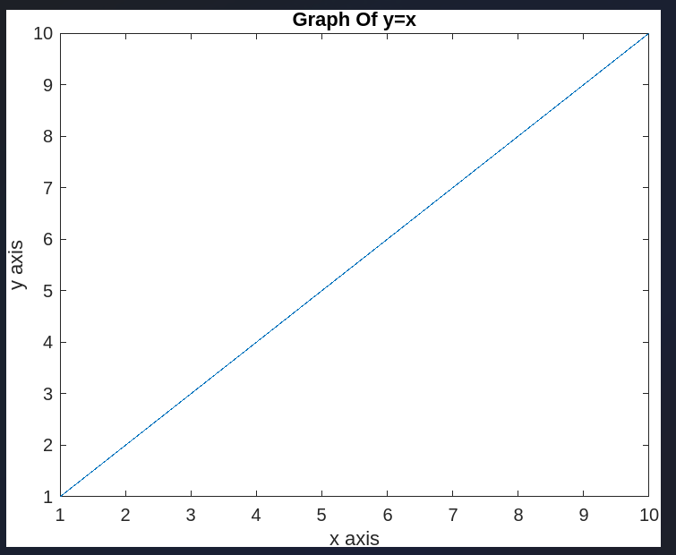 - Plot graph y = x and x = (1,2,3…….10).

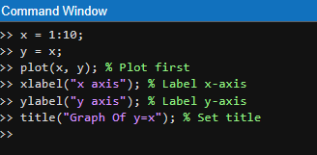

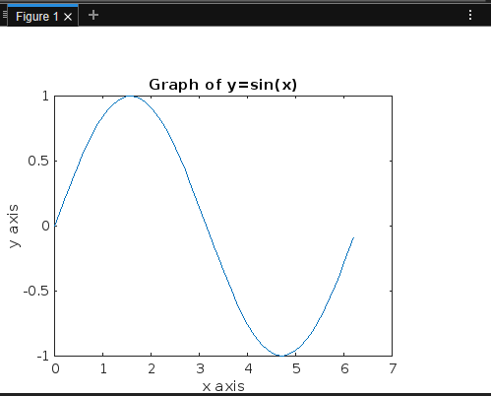- Create an x vector (x = 0:0.1:2*pi) and a y vector (y = sin(x)), then plot the graph.

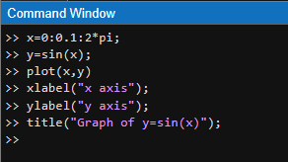

- Plot the graph y = $x^{2}$ and x in the range of (-3,3) increment 0.1

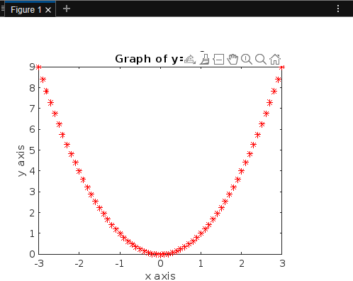 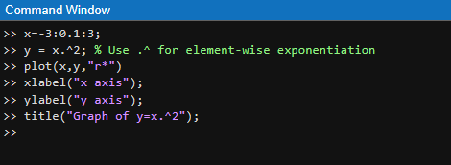

12. Loops and Conditional Statements.

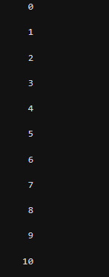 - Write a loop to print numbers from 1 to 10.

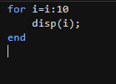

- Write an if-else condition to check if a number is positive or negative.

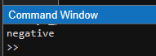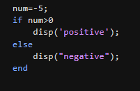

 - Add all the even numbers from 0 to 100 using for loop. 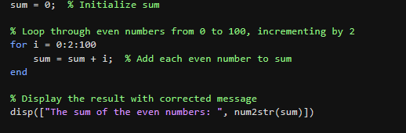

- Create a script that to find sum of “n” numbers using for loop.

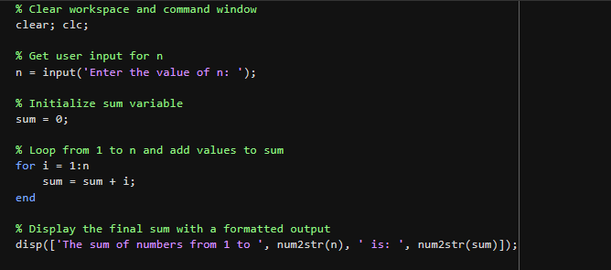

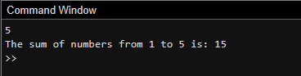

***Summary***

|  |  |
| --- | --- |
| **Command** | **Use / Description** |
| clc | Clears the **Command Window** |
| clear | Clears all **variables** from the workspace |
| disp('Hello World!') | Displays text in the **Command Window** |
| date | Displays the **current date** |
| x = 5; X = 10 | Defines variables and shows **case sensitivity** (x ≠ X) |
| ; (semicolon) | **Suppresses output** in Command Window |
| diary filename.txt | Records session in a **text file** |
| who | Lists **variable names** currently in the workspace |
| whos | Lists variables with **details** (size, bytes, class, etc.) |
| a + b, a * b | Performs **arithmetic operations** |
| a^b, exp(a) | **Power** and **exponential** operations |
| V(2) | Accesses the **2nd element** of a vector |
| zeros(1, 5) | Creates a **row vector** with five zeros |
| zeros(5, 1) | Creates a **column vector** with five zeros |
| 0:10 | Creates a vector from 0 to 10 in **steps of 1** |
| 0:2:10 | Creates vector: [0 2 4 6 8 10] |
| M = rand(3,3) | Creates a **3x3 random matrix** |
| M(2,3) | Accesses the element at **2nd row, 3rd column** of matrix M |
| M + 2 | Adds 2 to **each element** of matrix M |
| websave(filename, url) | **Downloads** image from the internet and saves it |
| imread('image.jpg') | **Reads** an image file |
| imshow(img) | **Displays** the image in a figure window |
| imwrite(img, 'out.jpg') | **Writes** the image to a file |
| plot(x, y) | Plots a **2D graph** |
| x = 0:0.1:2*pi | Creates a **vector from 0 to 2π** with increment of 0.1 |
| y = sin(x) | Calculates **sine** of each element in x |
| for i = 1:10 | Starts a **for loop** from 1 to 10 |
| if x > 0 ... else ... | **Conditional statement**: checks if value is positive or negative |
| sum = 0; for i=1:n ... | Sums first n numbers using a **for loop** |